
β-catenin (G48D)
Catalog Number: CR-M26166
Gene Symbol: CTNNB1, CTNNB
Description: Anti-β-catenin (G48D) Mouse Monoclonal Antibody

Background: Beta-catenin (or β-catenin) is a protein that in humans is encoded by the
CTNNB1 gene. β-catenin is a subunit of the
cadherin protein complex and also acts as an
intracellular signal transducer in the Wnt
signaling pathway. Deregulation of beta-catenin signaling is an important event in the genesis of a number of malignancies, such as colon cancer, melanoma, hepatocellular carcinoma, ovarian cancer, endometrial cancer, medulloblastoma
pilomatricomas, and prostate cancer.
Immunogen: A synthetic peptide from the
internal region of β-catenin which includes the mutation of G48D, human origin.
Tested applications: ELISA, WB, IF, IHC Recommended dilutions:
ELISA: 1:1000-1:5000
WB: 1:500-1:2000
IHC: 1:50-1:100
Concentration: 1 mg/ml
Host: Mouse
Clonality: Monoclonal
Purity: Purified from ascites
Format: Liquid Storage buffer:
Preservative: no
Constituents: PBS (without Mg2+ and Ca2+), pH 7.4, 150 mM NaCl, 50% glycerol
Species Reactivity: Recognizes β-catenin
(G48D), but not wild type β-catenin protein from vertebrates.
Storage Conditions: Store at -20°C. Avoid freeze / thaw cycles.

Western blot:

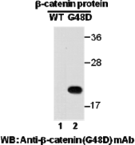
Western blot analysis of recombinant
β-catenin (G48D) and wildtype proteins.
Purified His-tagged β-catenin (G48D) protein
(amino acids 1-76, lane 2) and corresponding
wild type protein (lane 1) were blotted with anti- β-catenin (G48D) mouse monoclonal antibody (Cat. #26166).

For research use only. Not for diagnostic or therapeutic applications.

Immunofluorescence:
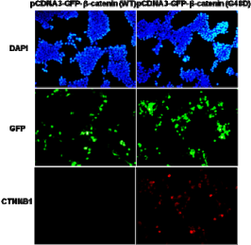
Immunofluorescence of cells expressing
β-catenin proteins with anti- β-catenin (G48D) antibody. HEK293T cells were transfected with pCDNA3-GFP-β-catenin (WT) plasmid (left
column) or pCDNA3-GFP-β-catenin (G48D)
plasmid (right column), then fixed and stained
with anti- β-catenin (G48D) monoclonal antibody (Cat. #26166).

